**RESUME OF MD.MOHSIN**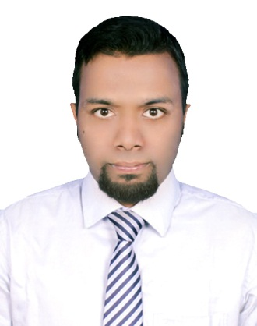

Address : F-23,20 Mile,Jahangirnagar University,Savar,Dhaka-1342.

Mobile No : 01760389641.

E-mail : msnju2010@gmail.com.

# Career Objectives:

Aiming for employment with strong sense of responsibilities which would help me to utilize my academic background that assist me to gain experience, employ my excellent interpersonal skills, and enable me to make a positive contribution.

# Career Summary:

1. To obtain a challenging position that will facilitate career development & generate opportunity to & contribute my education, experience, innovative and creative capability also very much interested in learning and exploring new technologies and platforms.

2. Academic Experienced in Web-Development, IT System Management,E-Commerce.

**Software Development Tools:**

Software Development Tracking : GIT.

Languages (Web App. Development) : PHP.

Framework : Laravel.

Front-End Development : HTML,CSS,Bootstrap,Template.

Database : MySql.

**Academic Qualification:**

|  |  |  |  |  |  |
| --- | --- | --- | --- | --- | --- |
| Exam Title | Major/Group | Institute | Result | Pass. Year | Duration(Year) |
| M.Sc. | Information  Technology | Jahangirnagar  University | - | 2017 | 1 |
| B.Sc. | Information Technology | Jahangirnagar  University | 3.04 | 2016 | 6 |
| H.S.C. | Science | J.U.School  &  College | 5.00 | 2010 | 2 |
| S.S.C | Science | J.U.School  &  College | 5.00 | 2008 | 2 |

**Career & Application Information:**

Looking For : Entry Level Job.

Available For : Contract.

Preferred Job Category : IT/Telecommunication, E-Commerce,

IT System Management, Website.

Preferred District : Dhaka.

Preferred Organization Types : Software Company.

# Academic Development Experience:

1. E-Commerce website/app development in CMS (Ecommerce Platform).
2. Web-Application development in Laravel Framework.
3. Wordpress Theme & Plugin Development.
4. Graphic Design(Adobe Photoshop, Adobe Illustrator).
5. Search Engine Optimization (SEO).
6. Networking(CISCO,CCNA,CCNP,Topology Setup, Packet Tracer, Network Infrastructure Installation ).

# Personal Details:

Father’s Name : Md.Ramzan Ali

Mother’s Name : Mosammad Morium Begum .Date of Birth : 4 January, 1992

Gender : Male

Marital Status : Unmarried

Nationality : Bangladeshi

Religion : Islam Current Location : Dhaka

# References:

Name : Dr.Mohammad Shahidul Islam Organization : Jahangirnagar University

Designation : Associate Professor of IT

Address : <http://people.juniv.edu/profile/sislam>

Mobile : 01714028777

Email : [suva93@gmail.com](mailto:suva93@gmail.com)

Relation : Academic

Md.Mohsin

____________________________

**Name & Signature Of Applicant**